Screenshot 1: After completing Task 1: you will include the screenshot for Task 1: Store a Publicly Accessible Image File in an Amazon S3 Bucket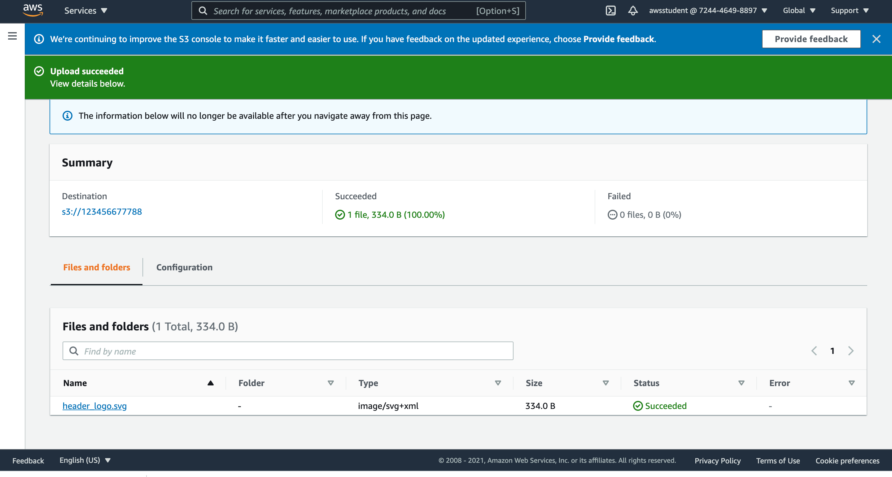

Screenshot 2: After completing Task 2, you will include the screenshot for Task 2: Create an Amazon CloudFront Web Distribution.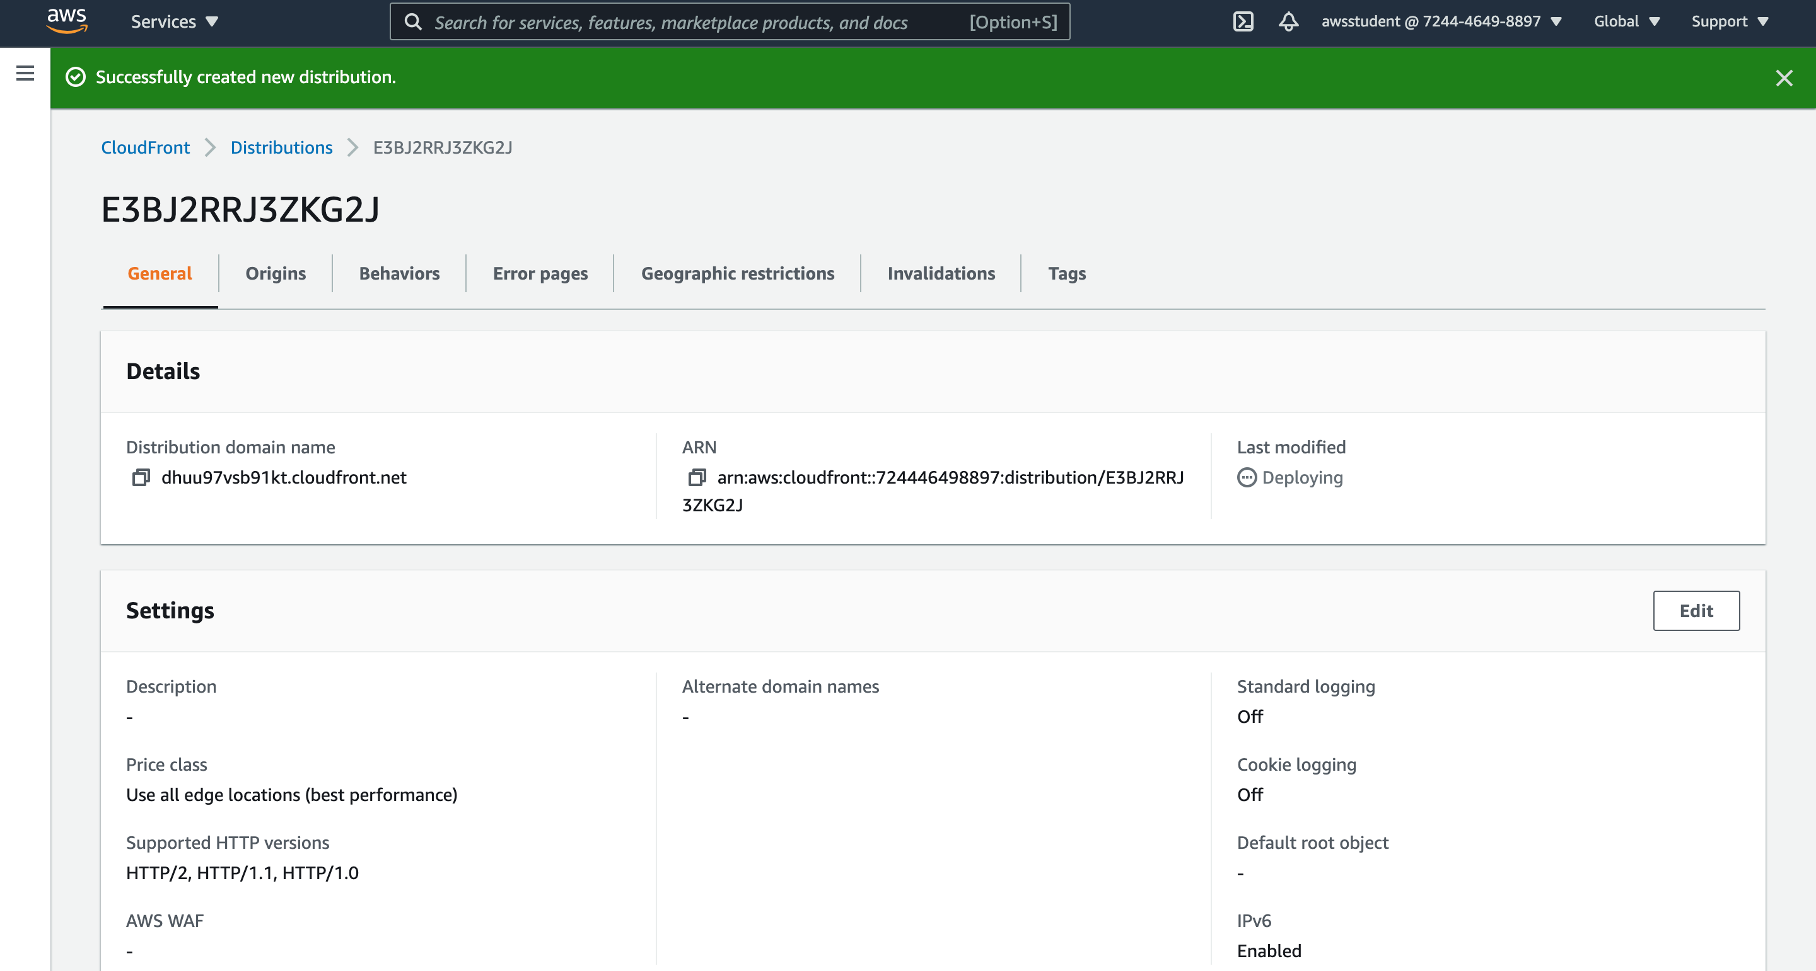

Screenshot 3: After completing Task 3, you will include the screenshot for Task 3: Create a link to your object.

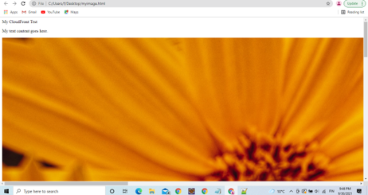

Screenshot 4: After completing Task 4, you will include the screenshot for Task 4: Delete Your Amazon CloudFront Distribution.

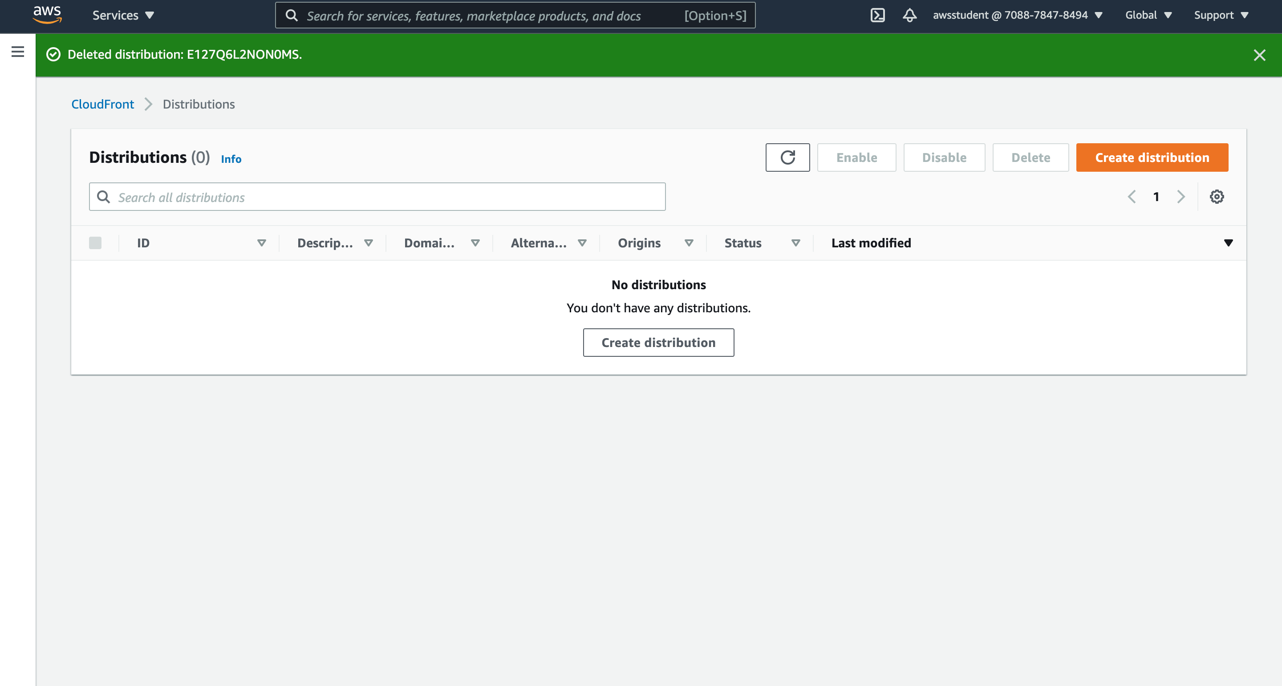

Screenshot 5: After completing Task 5, you will include the screenshot for Task 5: Delete your Amazon S3 Bucket.